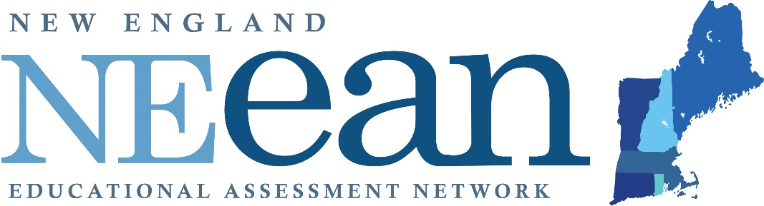

Fall Forum 2018
An Annual Assessment Conference
Call for Proposals
Inclusive and Meaningful Assessment
College of the Holy Cross, Worcester, MA
Friday, November 2, 2018

The New England Educational Assessment Network organizes this annual conference for presenters to discuss their research and assessment projects with colleagues from across the region. This year, presentations on diversity and inclusive assessment will be given priority in the selection process.
In addition, NEean welcomes proposals that reflect a range of assessment topics, including:
- Changes in curriculum and pedagogy that result in a better understanding of the teaching and learning process.
- Integrative assessment projects that serve to break down silos and inspire collaboration.
- Assessment of all areas of college and university life, including academic programs, student services, academic supports and business units.
- Course, program and institutional level assessment projects that demonstrate how data was used to positively impact student success.

Proposal System Opens June 8 at
https://easychair.org/conferences/?conf=neeanff2018

Submission Deadline: July 23, 2018
More information? http://neean.org/event-2934871

